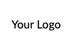
[Your Website]
[Your Email]
Insert the above information and copy and paste to each cell

